PRODUCT INFORMATION FILE*

RégimA Company

Neck + Breast Refining Complex Masque

Prepared: May 2018
(Label & packaging update August 2021)

*As required under Article 11 of the European Cosmetics Regulation EC No. 1223/2009
TABLE OF CONTENTS

Contents
INTRODUCTION 3
PRODUCT DESCRIPTION 3
COSMETIC PRODUCT SAFETY REPORT 7
Part A: Cosmetic Product Safety Information 7
A.1 Quantitative and qualitative composition of the cosmetic product: 7
A.2 Physical /chemical characteristics and stability of the cosmetic product 11
A.3 Microbiological Quality 12
A.4 Impurities, traces, information about the packaging material 12
A.5 Normal and reasonably foreseeable use 12
A.6 Exposure to the Cosmetic Product 12
A.7 Exposure to the Substances 13
A.8 Toxicological Profile of the Substances 15
A.9 Undesirable Effects and Serious Undesirable Effects 19
A.10 Information on the Cosmetic Product 19
B: Part Cosmetic Product Safety Assessment 20
B.1 Assessment Conclusion 20
B.2 Label Warnings and Instructions for Use 20
B.3 Reasoning 21
B.4 Assessors Credentials and Approval of Part B 21
List of References 21
METHOD OF MANUFACTURE / GMP CERTIFICATION 22
PROOF OF EFFECT CLAIMED 23
ANIMAL TESTING STATEMENT 23
Appendix 1: Safety Data Sheets or Ingredient Specifications 24
Appendix 2: Microbial Challenge Test 25
Appendix 3: Certificates of Allergen Content 26
Appendix 4: Miscellaneous 27

INTRODUCTION

PRODUCT DESCRIPTION

Product Name: Neck + Breast Refining Complex Masque

Product type | Neck, décolleté and breast cream
Form | Cream
Colour | Off white
Pack size | 50 ml & 150ml
Pack type | Chubby Chunky Airless Containers
Dispenser type | Polypropylene pump
Part of a set | No
Manufacturer code | SBRR 002
Normal use | Directions: 50ml. AM & PM; Cleanse with RégimA, apply eye care products. Apply a thin layer of Neck + Breast Complex to neck, décolleté and breasts. To be followed daily by application of RégimA day product containing sun protection.  150ml: To be used as part of a RégimA in-salon treatment. This Neck + Breast Complex may be used as a Masque during a RégimA facial. Apply a think layer to neck, décolleté and breasts. This may be left on and additional hydrating or treatment products applied over if desired.

Pictures of the Item: On following page
Container label

Neck + Breast Refining Complex – 50ml

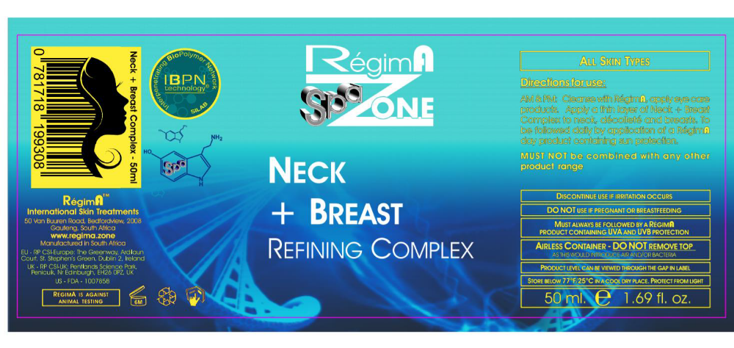

Carton label
Neck + Breast Refining Complex – 50ml

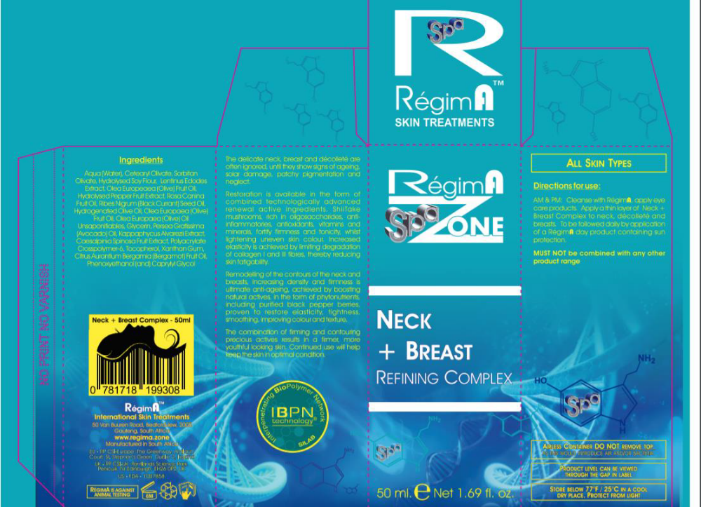
Batch code: The batch number is printed onto the underside of the carton and the container at the point of manufacturing and filling; therefore, it is not visible on the label as represented in this PIF. The batching is automated, so the batch code and date is printed onto the carton and container as they are filled and boxed.

Product claims:

This product claims the following:

Restoration is available in the form of combined technologically advanced renewal active ingredients. Shiitake mushrooms, rich in oligosaccharides, anti-inflammatories, antioxidants, vitamins and minerals, fortify firmness and tonicity whilst lightening uneven skin colour. Increased elasticity is achieved by limiting degradation of Collagen I and III fibers, thereby reducing skin fatigability.

Remodeling of the contours of the neck and breasts, increasing density and firmness is ultimate anti-ageing, achieved by boosting natural actives in the form of phytonutrients, including purified black pepper berries, proven to restore elasticity, tightness, smoothing, improving colour and texture.

The combination of firming and contouring precious actives results in a firmer, more youthful looking skin.

COSMETIC PRODUCT SAFETY REPORT

Part A: Cosmetic Product Safety Information

A.1 Quantitative and qualitative composition of the cosmetic product:

Neck + Breast Refining Complex Masque base formula

No | Raw Ingredient (INCI Name) | % (w/w) | Mixture % w/w Wt(g/kg) | CAS | EC | Function | Supplier (Agent) | Tradename
1 | Water (Aqua) | 5 | 5 | 7732-18-5 | 231-791-2 | Solvent | In House | Deionised Water
2 | Cetearyl Olivate | 2.5 | 5 | 85116-80-9 | 285-532-3 | Emulsifying | Textron Tecnica (CJP Chemicals) | Olivem® 1000
2 | Sorbitan Olivate | 2.5 | 5 | 223706-40-9/  92202-01-2 | 296-033-5 | Emulsifying | Textron Tecnica (CJP Chemicals) | Olivem® 1000
3 | Water (Aqua) | 4.85 | 5 | 7732-18-5 | 231-791-2 | Solvent/  Emulsifying/  Skin Conditioning/  Preservative | Silab (Meganede) | Raffermine® 2
3 | Glycine Soja Protein | 0.075 | 5 | 9010-10-0 | 232-720-8 | Solvent/  Emulsifying/  Skin Conditioning/  Preservative | Silab (Meganede) | Raffermine® 2
3 | Phenoxyethanol | 0.075 | 5 | 122-99-6 | 204-589-7 | Solvent/  Emulsifying/  Skin Conditioning/  Preservative | Silab (Meganede) | Raffermine® 2
4 | Water (Aqua) | 4.35 | 5 | 7732-18-5 | 231-791-2 | Solvent/  Skin Conditioning | Silab (Meganede) | Fermiskin™
4 | Pentylene Glycol | 0.375 | 5 | 5343-92-0 | 226-285-3 | Solvent/  Skin Conditioning | Silab (Meganede) | Fermiskin™
4 | Lentinus Edodes Extract | 0.275 | 5 | 223748-90-1 | 310-127-6 | Solvent/  Skin Conditioning | Silab (Meganede) | Fermiskin™
5 | Olea Europaea Fruit Oil | 4 | 4 | 8001-25-0 | 232-277-0 | Masking/  Perfuming/  Skin Conditioning | Textron Tecnica (CJP Chemicals) | Olive Oil Extra Virgin
6 | Water (Aqua) | 2.916 | 3 | 7732-18-5 | 231-791-2 | Solvent/  Skin Protecting/  Preservative /  Skin Conditioning | Silab (Meganede) | Retilactyl D®
6 | Hydrolyzed pepper fruit extract | 0.063 | 3 | 84929-41-9 | 284-524-7 |  | Silab (Meganede) | Retilactyl D®
6 | Phenoxyethanol | 0.015 | 3 | 122-99-6 | 204-589-7 |  | Silab (Meganede) | Retilactyl D®
6 | Ethylhexylglycerin | 0.006 | 3 | 70445-33-9 | 408-80-2 |  | Silab (Meganede) | Retilactyl D®
7 | Rosa Canina Fruit Oil | 3 | 3 | 84696-47-9/  84603-93-0 | 283-652-0 | Emollient/  Skin Conditioning | Seatons (Croda) | Rose Hips Oil
8 | Ribes Nigrum Seed Oil | 3 | 3 | 68606-81-5/  97676-19-2 | 271-749-0 | Emollient | Textron Tecnica (CJP Chemicals) | Blackcurrant Seed Oil
9 | Hydrogenated Olive Oil | 1.95 | 3 | 226993-75-5/  68334-28-1 | 269-820-6 | Skin Conditioning/  Viscosity Controlling/  Masking/  Perfuming/  Skin Conditioning | Textron Tecnica  (CJP Chemicals) | Oliwax
9 | Olea Europaea Fruit Oil | 0.825 | 3 | 8001-25-0 | 232-277-0 |  | Textron Tecnica  (CJP Chemicals) | Oliwax
9 | Olea Europaea Oil Unsaponifiables | 0.225 | 3 | 8001-25-1/  156798-12-8 | 232-277-0 |  | Textron Tecnica  (CJP Chemicals) | Oliwax
10 | Glycerin | 3 | 3 | 56-81-5 | 200-289-5 | Humectant/  Perfuming/  Skin Protecting/  Viscosity Controlling | Various | Refined Glycerin
11 | Persea Gratissima Oil | 2 | 2 | 8024-32-6 | 232-428-0 | Skin Conditioning | Textron Tecnica (CJP Chemicals) | Avocado Oil
12 | Polyacrylate Crosspolymer-6 | 0.95 | 1 | # | # | Perfuming/  Solvent /  Emulsion Stabilising/  Viscosity Controlling | Seppic (CJP) | Sepimax Zen
12 | T-Butyl Alcohol | 0.05 | 1 | 75-65-0 | 200-889-7 |  | Seppic (CJP) | Sepimax Zen
13 | Phenoxyethanol | 0.9 | 1 | 122-99-6 | 204-589-7 | Preservative/  Emollient/  Humectant/  Skin Conditioning | Dr Straetmans (Meganede) | Verstatil PC
13 | Caprylyl Glycol | 0.1 | 1 | 1117-86-8 | 214-254-7 | Preservative/  Emollient/  Humectant/  Skin Conditioning | Dr Straetmans (Meganede) | Verstatil PC
14 | Caesalpinia spinosa fruit extract | 0.475 | 1 | 39300-88-4 | 254-409-6 | Skin Protecting/  Skin Conditioning/  Solvent | Silab (Meganede) | Filmexel®
14 | Kappaphycus alvarezii extract | 0.475 | 1 | 1220882-73-4 | 310-127-6 | Skin Protecting/  Skin Conditioning/  Solvent | Silab (Meganede) | Filmexel®
14 | Water (Aqua) | 0.05 | 1 | 7732-18-5 | 231-791-2 | Skin Protecting/  Skin Conditioning/  Solvent | Silab (Meganede) | Filmexel®
15 | Citrus bergamia peel oil expressed  (also known as the perfuming name: Citrus Reticulata, X C. Sinensis Peel Extract) | 1 | 1 | 93686-22-7 | 297-672-2 | Perfuming | FD Copeland (CJP Chemicals) | Bergamot Oil
16 | Xanthan Gum | 0.25 | 0.25 | 11138-66-2 | 234-394-2 | Binding/  Emulsifying/  Emulsion Stabilising/  Gel Forming/  Skin Conditioning/  Surfactant/  Viscosity Controlling | CP Kilco (Tranarc) | Xanthan Gum
17 | Tocopherol | 0.1 | 0.1 | 54-28-4 (gamma)/  16698-35-4 (beta)/  10191-41-0(DL)/  119-13-1/  1406-18-4/  406-66-2/  2074-53-5 (DL)/  59-02-9 (D)/  616-22-0 | 200-201-5/  240-747-1/  233-466-0/  204-299-0/  215-798-8/  218-197-9/  200-412-2 | Antioxidant/  Masking/  Skin Conditioning | DSM Nutritional Products (Chempure) | dl-α- Tocopherol
18 | Water (Aqua) | 54.65 | 54.65 | 7732-18-5 | 231-791-2 | Solvent | In House | Deionised Water
# CAS/ EC not assigned

Ingredient order for the label: Water (Aqua), Olea Europaea Fruit Oil, Glycerine, Ribes Nigrum Seed Oil, Rosa Canina Fruit Oil, Cetearyl Olivate, Sorbitan Olivate, Persea Gratissima Oil, Hydrogenated Olive Oil, Citrus bergamia Peel Oil expressed, Phenoxyethanol, Polyacrylate Crosspolymer-6, Caesalpinia Spinosa Fruit extract, Kappaphycus alvarezii extract, Pentylene Glycol, Lentinus Edodes Extract, Limonene, Xanthan Gum, Olea Europea Oil Unsaponifiables,
Linalool, Caprylyl Glycol, Tocopherol, Glycine Soja protein, Hydrolyzed pepper fruit extract, T-butyl alcohol, Citral, Ethylhexylglycerin, Linalyl Acetate, Pinene.

Red font denotes ingredients present at less than 1% which may be listed in any order.
Below are the allergens and their respective concentrations in the fragrance that are required to be listed in Article 19 Paragraph 1(d) & (g (ii)) of EC 1223/2009 when present at levels >0.001% in a leave-on product.

Fragrance allergens

INCI (EU) Name | CAS number | EC number | Concentration % w/w | Comment
Citral | 5392-40-5 | 226-394-6 | 0.0301 | Annex III/70*
Limonene | 5989-27-5 | 227-813-5 | 0.2735 | Annex III/88*
Linalool | 78-70-6 | 201-134-4 | 0.1005 | Annex III/84*
Linalyl Acetate | 115-95-7 | 204-116-4 | 0.25 | SCCS Opinion on Fragrance allergens, Page 47 2*
Pinene | 80-56-8 | 201-291-9 | 0.029 | SCCS Opinion on Fragrance allergens, Page 47 2*
*Regulation (EC) No 1223/2009 of the European Parliament and of the council of 30 November 2009 on cosmetic products, Annex III – List of substances which cosmetic products must not contain except subject to the restrictions laid down.
** SCCS Opinion on Fragrance allergens in cosmetic products, 15th plenary meeting, June 2012, SCCS/1459/11, Section 7-1 – Tabular summary of evaluated individual fragrance chemicals, Table 7-1 Established Contact allergens in humans.

A.2 Physical /chemical characteristics and stability of the cosmetic product

Physical and chemical characteristics of the ingredients have been listed in the safety data sheets which are maintained electronically by the Responsible Person and are available on request. A cross reference to the SDS tradename and electronic reference number has been shown in the base formula table.

Physical and Chemical Characterization of the product

1 Physical state | Cream
2 type of mixture (emulsion/ o/w or w/o, suspension, lotion, powder, aerosol …) | Emulsion
3 organoleptic properties (colour, odour, whenever relevant) | Off white smooth cream. Characteristic odour
4 pH (at 25ºC) | 4.74
5 viscosity (at 25ºC⁾ | 85,000
6 thermal stability (glass bottle) | 40 ºC for 12 weeks
7 Specific gravity (at 25ºC⁾ | 0.960 g/ml

Stability of the product

A shelf-life of 6 months after opening has been allocated to this product.

An on-going stability study of the product in the packaging will be available to support the shelf-life. A stability test of the product in glass jars has confirmed stability at 25ºC for 12 weeks.

Additional stability tests were performed at 5ºC, 40ºC and 50ºC.

5ºC Stability testing
Testing at 5ºC noted an increase in viscosity at week 4, 8 and 12 where the increase was noted as 18%, 57% and 29% respectively.

40ºC Stability testing
At 40ºC the products appearance was noted as changed, the change was noted in week 4 onwards where the change was described as very slightly darker. The pH had reduced in week 8 and 12 by 11% and 12% respectively. Viscosity testing at 40ºC indicated a significant change in week 1, 2 and week 4 where changes were noted as 16%, 23%, (-)34%

50ºC Stability testing
Stability at 50ºC indicated that the products appearance had changed from week 4 through to week 12 where it was noted as ‘v. slightly darker’. The pH had noticeable dropped in week 4, 8 and 12 where the drop was noted as 17%, 22% and 19% respectively.

Additionally, the viscosity of the product was noted to have changed in week 1 and week 2 where the change was 14% in both tests.

A.3 Microbiological Quality

A PET test has been performed according to USP method 38 and confirms the effectiveness of the preservative for a period of 28 days. The certificate has been presented in Appendix 2.

A.4 Impurities, traces, information about the packaging material

None of the ingredients of this product contained impurities at a level which would require notification.

A statement on the suitability of the product packaging is shown below.

The Neck + Breast Refining Complex Chubby Chunky Airless Container is made from Polypropylene and ow density Polyethylene (LDPE). The pump is composed of Polypropylene, LDPE and high-density polyethylene (HDPE). The components of the packaging material and suitability of use criteria are included in a certificate in Appendix 4. This is maintained electronically with the PIF by the Responsible Person and is available on request.

A.5 Normal and reasonably foreseeable use
RégimA SpaZone Neck and Breast refining complex is a product designed for application to the neck, breast and décolleté as a refining complex. It is a leave-on product that in normal circumstances will be used once daily on the neck, break and décolleté. This product is an in-salon product (150ml) with a take home product also (50ml).

A.6 Exposure to the Cosmetic Product

Site of application | Neck, Breast and Décolleté
Surface area of application (cm²) | 2,722.5*
Volume of product applied (mg) | 3196**
Frequency of application/use per day | Twice daily#
Target population | Adults
Normal and foreseeable exposure route | Dermal
Calculated relative daily exposure according to SCCS notes for guidance tables (mg/kg bw/day) | 3.196g applied dermal to a human with a default weight of 60kg has determined a Relative Daily exposure of 53.27mg/kg bw/day
Dermal absorption information | None
other | NA
* Surface area of application = 2,722.5cm² has been extracted from the Nordic Exposure Group Project 2011, Existing Default Values and Recommendations for Exposure Assessment, TemaNord 2012:505. RegimA Neck & Breast refining complex is applied to the neck, breast and décolleté area, as there is no data directly outlining the surface areas of the intended areas an extraction was made. The Nordic Exposure Group Project 2011 has outlined the total body surface area of men and women to be 19,400 and 16,900cm² respectively with an average body area of 18,150cm². Referencing the Lund and Browder chart which outlines the % total body surface area burn, this chart is typically used in the assessment of burn victims. This chat is the most accurate method ad compensates the variation in body shape. The Lund and Browder chart indicates that the chest and neck (front and back) total 15% of the entire body, using this as the worst-case scenario the surface area of the neck and chest was calculated to be 2,722.5cm². It was concluded that the neck, break and décolleté totaled 25% (1/4) of the trunk of an adult giving a surface are of 1427.5cm². Hettiaratchy, S. and Papini, R. (2004). Initial management of a major burn: II—assessment and resuscitation. BMJ, 329(7457), pp.101-103.
** Volume of product applied = 3196mg/day, this has been extracted from Body cream/lotion data provided by CTFA where it states 1.12mg/cm²/day is applied. The surface area of application has been outlined as 1427.5 cm² therefore the amount applied was calculated as 1598 mg/per application, where the product is applied twice a day.
# Frequency of application/use per day: worst case scenario of application twice day based on the product being used at home.

A.7 Exposure to the Substances

Daily Systemic Exposure Dosage (SED) is the daily amount of a cosmetic substance applied based on the concentration of that particular substance, the percutaneous absorption and the nominal human body weight (60 kg) and this is shown in the table below.
Ingredient  (INCI name & CAS number) | Maximum concentration  (%) | Calculated product relative daily exposure (mg/kg bw/day) | Dermal penetration factor# | Daily ingredient exposure or SED  (mg/kg bw/day)
Olea Europaea Fruit Oil  8001-25-0 | 4.825 | 53.27 | 1 | 2.570
Glycerin  56-81-5 | 3 | 53.27 | 1 | 1.598
Ribes Nigrum Seed Oil  68606-81-5 | 3 | 53.27 | 1 | 1.598
Rosa Canina Fruit Oil  84696-47-9 | 3 | 53.27 | 1 | 1.598
Cetearyl Olivate  85116-80-9 | 2.5 | 53.27 | 1 | 1.332
Sorbitan Olivate  223706-40-9 | 2.5 | 53.27 | 1 | 1.332
Persea Gratissima Oil  8024-32-6 | 2 | 53.27 | 1 | 1.065
Hydrogenated Olive Oil  226993-75-5 | 1.95 | 53.27 | 1 | 1.039
Citrus bergamia peel oil expressed  (also known as the perfuming name: Citrus Reticulata, X C. Sinensis Peel Extract)  93686-22-7 | 1 | 53.27 | 1 | 0.533
Phenoxyethanol  122-99-6 | 0.99 | 53.27 | 1 | 0.527
Polyacrylate Crosspolymer-6  # | 0.95 | 53.27 | 1 | 0.506
Caesalpinia spinosa fruit extract  39300-88-4 | 0.475 | 53.27 | 1 | 0.253
Kappaphycus alvarezii extract  1220882-73-4 | 0.475 | 53.27 | 1 | 0.253
Pentylene Glycol  5343-92-0 | 0.375 | 53.27 | 1 | 0.200
Lentinus Edodes Extract  223748-90-1 | 0.275 | 53.27 | 1 | 0.146
Xanthan Gum  11138-66-2 | 0.25 | 53.27 | 1 | 0.133
Olea Europaea Oil Unsaponifiables  8001-25-1 | 0.225 | 53.27 | 1 | 0.120
Caprylyl Glycol  1117-86-8 | 0.1 | 53.27 | 1 | 0.05327
Tocopherol  54-28-4 | 0.1 | 53.27 | 1 | 0.05327
Glycine Soja Protein  9010-10-0 | 0.075 | 53.27 | 1 | 0.03995
Hydrolyzed pepper fruit extract  84929-41-9 | 0.063 | 53.27 | 1 | 0.03356
T-Butyl Alcohol  75-65-0 | 0.05 | 53.27 | 1 | 0.02663
Ethylhexylglycerin  70445-33-9 | 0.006 | 53.27 | 1 | 0.003196
# No dermal absorption data is available; 100% dermal absorption is used it is a leave on product.

A.8 Toxicological Profile of the Substances
Ingredient  (INCI name & CAS number) | Hazard ID and listª | Reference for hazard ID | Irritant to eyes | Irritant to skin | Sensitiser | Human data | NOAEL  (mg/kg bw/day) | SED^{b} | MoS^{c} | Comment
Polyacrylate Cross Polymer 6  # | C | - | Slightly irritating | Non-irritant | Non-senstizing | Non-sensitizing and non-irritating in humans at ~5% | Not available | Not available | Not available | Not genotoxic (negative bacterial revere mutation). Based on assumed low hazard (meets the NICNAS polymer of low concern criteria) and assessed use pattern (up to 5% in cosmetics), not considered to be an unreasonable health risk. No developmental or reproductive toxicological data is available for Polyacrylate Cross Polymer 6 therefore it is advised not to use it on pregnant or lactation females.
Olea Europaea Fruit Oil  8001-25-0 | A | 2014 CIR Compendium. For use up to 100%, Final report 03/11 available from CIR. the safety of Olea Europaea Fruit Oil  for use in pregnant or lactating mothers has not been confirmed therefore it is advisable not to use during pregnancy and lactation.
Glycerin  56-81-5 | A | GRAS, FDA approved food additive, FDA approved over the counter (OTC) for skin. In a 2-generation reproductive study in rats, (n=10/sex), the administration of glycerin (0, 20%; ~ 2000 mg/kg/d in drinking water) for 8 weeks before mating until weaning of pups produced no adverse effects on the reproductive efficiency of the parents (F₀ generation), or the growth, fertility, or reproductive performance of the untreated F₁ generation. No histological changes occurred in the tissues of either the F₁ or F₂ generations. The onset of estrus cycles, weight gain, and microscopic observations of the endocrine organs were comparable to those of the controls in both the F₁ and the F₂ generation. A NOAEL for maternal toxicity and teratogenicity was calculated to be 1310 mg/kg/d following the administration of glycerin to Wistar rats by oral gavage on days 6 through 15 of gestation where there was no adverse effects observed in the dams. A maternal toxicity MoS of 1640 was calculated where a MoS of greater than 100 represents safe use.  Final report 12/09/2014 available from CIR website.
Ribes Nigrum Seed Oil  68606-81-5 | A | 2014 CIR Compendium. For use up to 0.3%, Final Report 03/11 available from CIR. Ribes Nigrum Seed Oil is present in Neck and Breast Refining Complex at 3%, 10 times over the limited outlined by the compendium. The FDA have stated that Blackcurrant buds and leaves; under the name Ribes Nigrum L. are permitted as direct addition to food for human consumption, 21CFR172.510.  To determine the safety if Ribes Nigrum Seed Oil a read across to Ribes Nigrum L. leaves was performed. An assessment was performed by European Medicine’s Agency (EMA); A sub-acute repeated dose toxicity testing on rats was performed where daily doses of 2g/kg/day and 1.34 g/kg/day for 21 and 28 days respectively was administered. No signs of toxicity or gastric ulceration was observed.  2g/kg/day = 2,000mg/kg/day  1.34g/kg/day = 1,340 mg/kg/day  EMA/HMPC/745347/2016  The use of a conversion factor was required in order to obtain a mg/kg bw/day value which could then be used to assess the safety of Ribes Nigrum. The EFSA Guidance on default values stated that the conversion factor that is to be used in subacute rat studies is a factor of 0.12 this allows for the conversion of mg/kg to mg/kg bw/day. Therefore;  2,000 mg/kg bw/day x 0.12 = 240 mg/kg bw/day  1,340 m/kg bw/day = 160.8 mg/kg bw/day  EFSA Journal 2012;10(3):2579  The EMA has stated that there is no data is available on the use of Ribes Nigrum L leaves in fertility, pregnancy and lactation, therefore, use of Ribes nigrum L., folium cannot be recommended during pregnancy and lactation.  Ribes Nigrum Seed Oil is present in Neck and Breast Refining Complex at 1.598 mg/kg bw/day, 101 times lower than that outlined as lowest dose of 160.8mg/kg/ bw/day.  It was determined that Ribes Nigrum L. is safe for use as formulated however, the safety of Ribes Nigrum Seed Oil for use in pregnant or lactating mothers has not been confirmed therefore it is advisable not to use during pregnancy and lactation.
Rosa Canina Fruit Oil  84696-47-9 | A | 2014 CIR Compendium. For use up to 19%, Final Report 03/11 available from CIR. There is no reliable information on the safety of taking Rose Hip (Rosa Canina) Fruit oil during pregnancy and breastfeeding it is therefore advisable to avoid its application to the skin.
Cetearyl Olivate  85116-80-9 | A | 2014 CIR Compendium. Safe for use in cosmetics when formulated to be non-irritating, Final Report 03/2013 available from CIR. There is no reliable information on the safety of taking Cetearyl Olivate during pregnancy and breastfeeding it is therefore advisable to avoid its application to the skin.
Sorbitan Olivate  223706-40-9 | A | 2014 CIR Compendium. For use up to 7.5%, IJT 21 (S1):93-112,2002. No information was available on the reproductive and developmental effects if Sorbitan Olivate, data was available on comparable products named Sorbital and Sorbitan Stearate. The data indicated the following: Fatty acids are normal components of diet for which no data was available concerning reproductive or developmental toxicity. Sorbitol (2.5% to 10%) had no adverse effects on the reproduction of CD rats during a multigenerational feeding study. Hydrogenated starch hydrolysates (~7% sorbitol) were not reproductive toxins at doses of 3000 to 7000 mg/kg/day for 2 years. Additionally, Gravid female Wistar rats, 20 per group, were dosed once daily by gavage with 0, 500 or 1000 mg/kg bw/day sorbitan stearate on days 0-20 of gestation, and the animals were killed. The NOAEL for maternal toxicity and for teratogenicity was 1000 mg/kg bw/day. No test article-related embryotoxic results were reported. Final report 12/09/2014 available from CIR website.  A maternal toxicity MoS was calculated to be 751 (Maternal NOAEL 1000mg/kg bw/day ÷ SED 1.332 mg/kg bw/day), generally a MoS of greater than 100 is representative of safe.
Persea Gratissima Oil  8024-32-6 | A | 2014 CIR Compendium. For use up to 98%, Final amended Report 03/11 available from CIR; JEPT 4(4):93-103, 1980 (original) re-review IJT 22(S1):1-35, 2003. There is no reliable information on the safety of taking Persea Gratissima Oil  during pregnancy and breastfeeding it is therefore advisable to avoid its application to the skin.
Hydrogenated Olive Oil  226993-75-5 | A | 2014 CIR Compendium. For use up to 12%, Final Report 03/11 available from CIR. There is no reliable information on the safety of taking Hydrogenated Olive Oil during pregnancy and breastfeeding it is therefore advisable to avoid its application to the skin.
Citrus bergamia peel oil expressed  (also known as the perfuming name: Citrus Reticulata, X C. Sinensis Peel Extract)  93686-22-7 | B | Supplier IFRA certificate of conformity supplied and presented in Appendix 3. Maximum allowable concentration for Category 4C (Body Creams, Oils, Lotions) is 19.91%, actual concentration in Neck and Breast Refining Complex is 1%. Allergen components are declared in A1 Fragrance Allergen table. Safe for inclusion in this product. There is no reliable information on the safety of taking Citrus bergamia peel oil expressed during pregnancy and breastfeeding it is therefore advisable to avoid its application to the skin.
Phenoxyethanol  122-99-6 | A | 2014 CIR Compendium. For use up to 1%, JACT 9(2):259-77, 1990. A teratogenicity/reproduction study was performed with 50 mice (of each sex) who were give 0.25, 1.25 and 2.5% Phenoxyethanol in their diet. An additional 40 mice of each sex was used in the control group. The mice were administered the test substance in the feed for 7 days prior to mating, and throughout the remainder of the study. Mice in the high-dose group produced fewer litters per pair, had smaller litters, and produced fewer live pups per litter. The decrease in weight of live pups was dose dependent.  An additional crossover mating trial with a 7-day mating period, this was performed to determine which sex was affected by the administration of Phenoxyethanol. The study indicated that Phenoxyethanol was fetotoxic in the F₀ females. The only significant difference noted during the trial was in the female mice was an increased liver weight in the high-dose females.  In another phase of the study, the final litters obtained from the continuous breeding phase of the study were one to three mice of each sex from each litter were selected for breeding within their feeding group. Dose-dependent decreases were found in body weight at birth, weaning day, and breeding day in these mice, suggesting that Phenoxyethanol was toxic throughout lactation and postweaning.  The study concluded that 2.5% Phenoxyethanol in the diet was a reproductive toxicant in F₀ mice and produced a dose-dependent decrease in live pup weight during exposure of the F₀ mice. Phenoxyethanol was selectively fetotoxic to F₀ females. Continuous exposure to Phenoxyethanol reduced the body weights of the F₁, mice in a dose-dependent manner and produced mortalities of 39% in the mice of the 1.25% dose group and 87% in the mice of the 2.5% dose group. The weights of the F₂ generation were also decreased in a dose-dependent manner. Phenoxyethanol in the diet was toxic to newborn and young mice.  A teratogenicity study using New Zealand White (NZW) rabbits was performed with undiluted phenoxyethanol of a 99% purity which was applied to the shaved backs of 25 pregnant rabbits at doses of 300, 600 or 1000 mg/kg/day from day 6 through to day 18 of gestation. It was concluded that dermal treatment of NZW rabbits with Phenoxyethanol did not result in teratogenicity, embryotoxicity, or fetotoxicity even at doses that were maternally toxic (600 mg/kg/day). A maternal MoS was calculated to be 1,139 (600mg/kg bw/day ÷ SED 0.527 mg/kg bw/day). A MoS of greater than 100 is generally considered safe. With the above studies in mind it is advisable not to use Neck + Breast Refining Complex during while pregnancy or during lactation.
Caesalpinia spinosa fruit extract  39300-88-4 | 2# | A secondary assessment was performed on Caesalpinia Spinosa Fruit Extract. A dose range of from 1-5% was established, which was 1-10 times greater than the percentage indicated in Neck + Breast refining complex; 0.475%. A read across was also performed to Caesalpinia Spinosa Gum, this read across was justified as the gum is a plant material derived from the dried gummy exudate (plan secretion) of the Caesalpinia Spinosa. Both Caesalpinia Spinosa and Caesalpinia Spinosa fruit extract both originate from the Fabaceae family. Caesalpinia Spinosa Gum has been approved for use as a food ingredient by JECFA, with no ADI specified and is also present in the CIR Compendium with its use in cosmetics stated as safe for use up to 0.5%.  In order to determine the teratogenicity/reproductive potential of Caesalpinia Spinosa fruit extract a read across was performed to Caesalpinia Spinosa gum. This read across was justified as the gum is a plant material derived from the dried gummy exudate (plan secretion) of the Caesalpinia Spinosa.  A multigenerational reproduction study on Caesalpinia Spinosa gum was performed using groups of CD albino rats (22 days old) where the gum was administered to male and female rats at a dietary level of 5%( 50, 000ppm) through 3 successive generations where all mating involved 10 males and 20 females per group where the fertility was described as high. The litters were maintained until the end of lactation (21 days old), it was concluded that C Spinosa gum had no adverse effects on reproductive performance and in utero development. Data from two progeny selected as parental animals for subsequent generations (F1 and F2 parents) indicated that these animals had normal growth patterns and reproductive performance.  The teratogenicity and embryotoxicity of C spinosa gum was evaluated using Wistar/HAN rats where groups of 25 rats were fed diets containing 0, 1.25%, 2.5% or5% from days 6-16 of gestation. All females were killed on day 21 with fetuses removed by C section. Necropsy results did not reveal any abnormalities after external, visceral and skeletal examinations of fetuses, it was concluded that C spinosa gum did not induce maternal toxicity, embryotoxicity or teratogenicity where a NOAEL was considered to be <50,000ppm in diet. It was therefore concluded that Caesalpinia spinosa fruit extract was safe to use as an ingredient on pregnant consumers.
Kappaphycus alvarezii extract  1220882-73-4 | 2# | A secondary assessment was performed on Kappaphycus Alvarezii extract. A read across was performed to carrageenan as most carrageenan’s are extracted from Kappaphycus Alvarezii. Carrageenan is a relatively large molecule with average molecular weights of 200,000 – 400,000, thus reducing the potential of dermal penetration due to the large nature of the molecules. Carrageenan has also been categorized as GRAS by the United States FDA and has also been approved as a food additive under 21 CFR 172.620. The WHO has confirmed these findings and considers carrageenan safe for food use and that it is not necessary to specify an ADI for man. Kappaphycus Alvarezii extract is present in Neck + Breast Refining Complex at 0.475% and it was therefore concluded as safe for use as formulated. There is no reliable information on the safety of taking Kappaphycus Alvarezii extract during pregnancy and breastfeeding it is therefore advisable to avoid its application to the skin during these times.
Pentylene Glycol  5343-92-0 | A | 2014 CIR Compendium. For use up to 5%. A read across was performed to Propylene Glycol to determine the teratogenic/developmental potential of Pentylene Glycol. This read across was justified as Propylene Glycol (C₃H₈O₂) and Pentylene Glycol (C₅H₁₀O₂) differ by C₂H_{2.} The reproductive and developmental toxicity potential of Propylene Glycol (PG) was determined using multiple studies which utilized Swiss Albino mice, Dutch belted rabbits and female golden hamsters where the studies concluded that PG was not a reproductive or developmental toxicant. IJT 31 (S2):147-168, 2012.
Lentinus Edodes Extract  223748-90-1 | B | A safety assessment was performed by EFSA Panel on Dietetic on Lentinex®; an aqueous mycelial extract of Lentinula edodes (formally Lentinus Edodes). Lentinex® consists of approximately 98% water and 2% dry matter; containing β- Glucan Lectinan, free glucose and N-containing constituents). Lentinus Edodes is present in RégimA Neck + Breast Refining Complex as Silab’s ingredient Fermiskin®, where the composition is stated as Water (87%), Pentylene Glycol (7.5%) and Lentinus Edodes Extract (5.5%). A proposed intake of Lentinex® was estimated at 2.5mL; containing 1mg Lentinan (β-glucan)/ml that corresponds to 41.7 µg/kg body weight for a standard 60kg person, therefore 2.5 mg/kg bw/day. Repeated dose toxicity studies on Beta Glucan in oral intake by humans where 6 male subjects ingested milkshakes with beta-glucan for 28 days. The test subjects ingested 6g/day for 5 days, 35g/day for 2weeks and 50g/day from day 21 to 28. Human Dermal irritation studies of Beta-glucan (the subject groups and dose/concentrations were not stated) under an occlusive patch test indicated beta-glucan to be a non-irritant. Skin sensitization was evaluated on 213 male subjects, where a modified Draize “multiple insult patch test was applied. The occlusive patches were applied every other day for 10 applications. A 48-hour challenge was performed after a 10 to 14 days of a non-treatment period. Results indicated irritation during the induction however overall it was determined not to be a sensitizer. The Panel concluded that Lentinex® is safe for use as food ingredient at the proposed levels of intake; as outlined above. IJT 35(Suppl. 1):5-49, 2016. Scientific opinion on the safety of “Lentinus edodes extract” (Lentinex®) as a Novel Food ingredient, EFSA Panel on Dietetic Products, Nutrition and Allergies, EFSA Journal 2010; 8(7):1685. Additional information provided by Silab regarding Fermiskin® has eluded to it being nonirritating, sensitizing and no toxicity associated with acute toxicity testing. Presented in Appendix 4. Lentinus Edodes Extract is present in Neck + Breast Refining Complex at 0.275%; 0.146 mg/kg bw/day based on an average 60kg human, 17 times less than the worst-case dose of 2.5 mg/kg bw/day. It is not expected at the level outlined to cause any adverse outcome effects when used as directed. There is no reliable information on the safety of taking lentinus edodes extract during pregnancy and breastfeeding it is therefore advisable to avoid its application to the skin during these times.
Xanthan Gum  11138-66-2 | A | 2014 CIR Compendium. For use up to 6%, Final Report 09/12 available from CIR. A three generational reproductive toxicity study was performed where albino rats were fed dietary level of 0, 0.25 and 0.5 g/kg bw/day Xanthan Gum where the rats produced 2 letters per generation and the successive generations were selected from weanlings of the second litter. There were no significant differences in developmental parameters between test and control litters and no malformations were observed in any of the offspring. IJT 35(Suppl. 1):5-49, 2016
Olea Europaea Oil Unsaponifiables  8001-25-1 | A | 2014 CIR Compendium. For use up to 3%, Final report 03/11 available from CIR. There is no reliable information on the safety of taking Olea Europaea Oil Unsaponifiables during pregnancy and breastfeeding it is therefore advisable to avoid its application to the skin during these times.
Caprylyl Glycol  1117-86-8 | A | 2014 CIR Compendium. For use up to 5%, IJT 31 (S2):147-168, 2012. Caprylyl glycol was assigned a score of ‘low’ for reproductive toxicity based on negative results for surrogates in animal studies. Caprylyl glycol was assigned a score of Low for developmental toxicity based on negative findings in well-conducted animal studies for the surrogates. The report Caprylyl Glycol (CAS #1117-86-6) GreenScreen® for Safer Chemicals (GreenScreen®) Assessment, Environmental Defense Fund, February 2016 is presented in Appendix 4.
Tocopherol  200-201-5 | A | 2014 CIR Compendium. For use <=5%, IJT 21(S3):51-116, 2002; Final Report 03/2014 available from CIR. There is no reliable information on the safety of taking Tocopherol during pregnancy and breastfeeding it is therefore advisable to avoid its application to the skin during these times. An article in The Telegraph published in June 2006 outlined that experts were warning women not to take Vitamin E supplements during pregnancy as it may harm the unborn child. The article does outline that it was not recommended to take Tocopherol orally but due to limited information on its reproductive and developmental toxicity potential it is taken as a worst-case scenario. The article is presented in Appendix 4.
Glycine Soja Protein  9010-10-0 | A | For use up to 0.9% in leave on cosmetics. Glycine Soja Protein is GRAS for substances migrating to food from paper and paperboard products (CFR 182.90). Final report available from CIR Website. There is no reliable information on the safety of taking Glycine Soja Protein during pregnancy and breastfeeding it is therefore advisable to avoid its application to the skin during these times.
Hydrolyzed pepper fruit extract  84929-41-9 | B | Hydrolyzed Pepper fruit extract has been identified under REACH registration conditions as Pepper (Piper) P. Nigrum ext. with corresponding CAS and EC numbers. The dossier provided states Skin irritation/ corrosion was determined via calculation. It was determined as a Category 2 (irritant) based on GHS criteria; this was due to Pepper (piper)P. Nigrum extract having more than 10% of its constituents classified as Skin Irritant Category 2. The skin sensitization potential was evaluated from the ECHA Guidance on the Application of the CLP Criteria (2013); the ingredient overall has not been tested in vitro or in vivo however some of the ingredients present have been classified as skin sensitizers Category 1B and all are described as being present at above the CLP generic concentration limit of 1%. Pepper (Piper), P. nigrum ext. REACH dossier  Piperine is a naturally occurring alkaloid that is the major pungent compound found in spices including Piper nigrum L., a 90-day toxicity study in rats has established a NOAEL of 5mg/kg bw/day. A MoS of 1901 has been calculated; 5mg/kg bw/day ÷ SED of 0.00263 mg/kg bw/day = 1901. A MoS of greater than 100 is generally recognized as safe. Norwegian Scientific Committee for Food Safety (2016). Risk assessment of "other substances" -Piperine.  Hydrolyzed Pepper fruit extract is the active ingredient presented in Silab’s product Retilactyl D®, the dermal irritation and sensitization capacity of Retilactyl D® was evaluated on human skin where it was determined to be a non-irritant and non-sensitizing. It was determined that Hydrolyzed Pepper Fruit extract is safe for use in Neck and Breast Refining Complex at 0.063% (0.03356 mg/kg bw/day).  Regarding reproductive and developmental toxicity of Piperine a 14-day study in Swiss albino female mice concluded that that the results indicated that Piperine might interfere with several crucial reproductive events in a mammalian model showing significantly reduced implantation values. Norwegian Scientific Committee for Food Safety (2016). Risk assessment of "other substances" -Piperine. While the product is considered safe when used and directed and adverse effects are not expected, in consideration of the information regarding fertility, use of this product containing hydrolyzed pepper fruit extract by pregnant or lactating women is not advised and this has been stated on the label.
T-Butyl Alcohol  75-65-0 | A | 2014 CIR Compendium. For use up to 0.5%, IJT 24(2):1-20, 2005 (Amended) JACT 8(4):627-41, 1989 (original report). T-butyl Alcohol did not affect the in vitro fertilization capacity of mouse spermatozoa. Fetotoxicity generally increased with concentration and fetal weights were slightly depressed at concentrations of 0.5 to 1%. IJT 24(2):1-20, 2005 It was therefore concluded that the use of T-Butyl Alcohol in Pregnant and lactation females is not advised.
Ethylhexylglycerin  70445-33-9 | A | 2014 CIR Compendium. For use up to 8%, JT 32(Suppl. 3):5-21, 2013 The effects of Ethylhexylglycerin was evaluated on pregnancy and embryo-fetal development was evaluated in a prenatal developmental toxicology study on female rats. No treatment related changes were reveled following visceral and skeletal examinations, a NOAEL was considered to be 800 mg/kg. A reproductive and developmental toxicity MoS of 250,313 was determined for Ethylhexylglycerin (NOAEL 800mg/kg ÷ SEED 0.003196 mg/kg bw/day) and was therefore considered safe for use.
ª Some ingredients are excluded from a formal risk assessment where a recognized authority has published a review of the ingredient under similar conditions of use and concluded on safe use at the level of inclusion in the cosmetic product (Hazard ID=A). Hazard ID category B is for recognized authority reviews of the ingredient under similar conditions of use with restricted use or where the ingredient is contained in the annexes to Regulation (EC) No 1223/2009 (Hazard ID=B). Where hazard ID A or B is reported, the maximum allowed usage concentration should be stated.
^{b} all possible routes of exposure should be considered
^{c} A MoS of greater than 100 is considered to represent safe use
# Food item, hazard and exposure data not required.
2# Secondary assessment performed, presented in Appendix 4.

Fragrances:

Neck and Breast refining complex contains a fragrance called Bergamot Oil. The IFRA certificate and allergen content is presented in Appendix 3 with individual allergen concentrations are outlined in Section A.1.

A.9 Undesirable Effects and Serious Undesirable Effects

No undesirable effects are anticipated based on the product being used as directed on the Neck and Breast area once daily.

A.10 Information on the Cosmetic Product

Neck and Breast refining complex was released in July 2017. Over the period July 2017 to May 2019 3823 units have been sold and there have been no adverse reactions reported to RégimA Company.

B: Part Cosmetic Product Safety Assessment

B.1 Assessment Conclusion

Review of the ingredients

After analysis of all the available information including:
- formulation
- toxicological profile of the ingredients and their concentration in the product
- Product data sheets supplied by the ingredient manufacturer

It is not expected that Neck and Breast Refining Complex will cause damage to human health when used as directed.

It is therefore concluded that Neck and Breast Refining Complex can placed on the market in the EU as a body cream for application to the neck and breast. While the product is considered safe for use when used as directed, it is not recommended for use by pregnant and breastfeeding women to avoid the possibility of adverse effects occurring to both the mother and breastfeeding child.

Review of human data on the product

There are no human tests such as a patch test, for this product.

B.2 Label Warnings and Instructions for Use

Directions for use are given on the product label and external packaging that is presented in Appendix 4.

Directions:

50ml
AM & PM: Cleanse with RégimA, apply eye care products. Apply thin layer of Neck + Breast Complex to neck, décolleté and breasts. To be followed daily by application of a RegimA day product containing sun protection.

100ml
To be used as part of a RégimA in-salon treatment.

This Neck + Breast Complex may be used as a Masque during a RégimA facial. Apply a thin layer to neck, décolleté and breast. This may be left on and additional hydrating or treatment products applied over if desired.

An IBPN label is attached to the product label and the outer packaging, this represents RégimA’s certification to use Silab’s Interpenetrating BioPolymer Network technology. The certificate is presented I Appendix 4.

Warnings:

50ml
‘Must not be combined with any other product range’

‘Airless container DO NOT remove top as this would introduce air and/or bacteria’

‘Product level can be viewed through the gap in label’

‘Store below 77°F / 25°C in a cool dry place. Protect from light’

‘Use sun protection’

‘Do not use if Pregnant or breastfeeding’

‘Discontinue use if irritation occurs.’

100ml
‘To be used as part of a RégimA in-salon treatment’

‘Strictly for professional use’

‘Airless container DO NOT remove top as this would introduce air/or bacteria’

‘Product level can be viewed through the gap in label’

‘Store below 77°F / 25°C in a cool dry place. Protect from light’

‘Use sun protection’

‘Do not use if Pregnant or breastfeeding’

‘Discontinue use if irritation occurs.’

B.3 Reasoning

This product contains many ingredients with a positive reputation for their body moisturising properties and with good local tolerance. There are no reasons to anticipate tolerance problems with use.

This product is intended for external use in adults only.

B.4 Assessors Credentials and Approval of Part B

Shirley Hudson (safety assessor)
BSc, University of Aberdeen
CBiol, MSB
20+ years as a practicing toxicologist in the pharmaceutical and chemical industries


After analyzing of all of the available information including the product formulation and toxicological profile of the ingredients, I conclude that according to the current state of scientific knowledge, this product is not expected to result in any significant damage to human health and can be safely marketed for the intended and foreseeable use as a Neck and breast moisturizer.

List of References

SCCS Notes of Guidance for the Testing of Cosmetic Substances and Their Safety Evaluation, 9th Revision, 29 September 2015 (SCCS/1564/15)
European Commission database on cosmetic ingredients (Cosing) http://ec.europa.eu/consumers/cosmetics/cosing/
Cosmetic ingredient review http://www.cir-safety.org/

METHOD OF MANUFACTURE / GMP CERTIFICATION

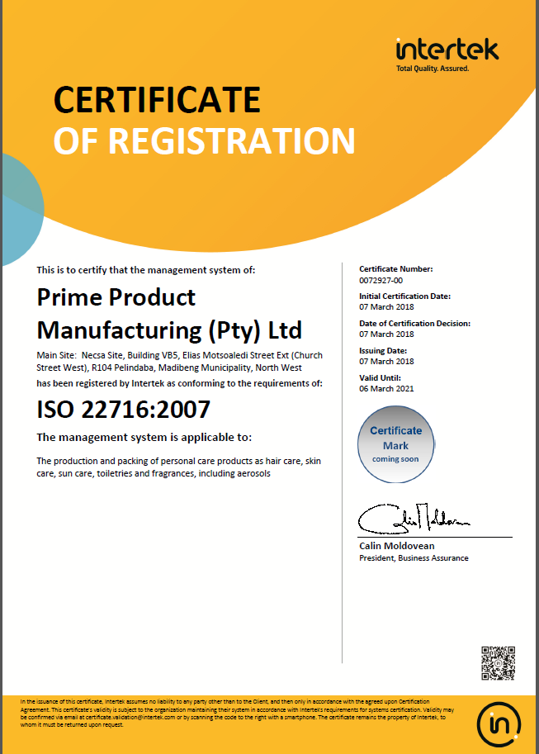

PROOF OF EFFECT CLAIMED

This product claims to:
- Fortify firmness and tonicity while lightening uneven skin colour
  - This claim has been substantiated by additional information provided on the ingredient Retilactyl D®. Retilactyl D® is a target solution for forming up the supporting tissues in the skin. In Vitro and In vivo studies confirmed the cosmetic efficacy of Retilactyl D® when used in cosmetic products. The documentation is presented in Appendix 4.
- Increased elasticity is achieved by limiting degradation of collagen I and II fibers, therefore reducing skin fatigability
  - This claim has been substantiated by the ingredient Reffermine®, this ingredient by Silab claims to improve skin tone and elasticity due to it being rich in glycoproteins and polysaccharides of soyabean membranes. This effect has been confirmed by In Vitro Studies and In Vivo human studies; the document is presented in Appendix 4.
- Remodeling of the contours of the neck and breasts, increasing density and firmness
  - This claim has been substantiated by the additional information provided on the Ingredient Fermiskin® by Silab. Fermiskin® utilizes the firming agents, Oligosaccharides and Galacturonic acids, found in Shiitake mushrooms. In Vitro and In Vivo cosmetic efficacy is outlined in Appendix
- Firming and contouring precious actives results in a firmer, more youthful looking skin.
  - This claim has been substantiated by the additional information provided on the Ingredient Fermiskin® by Silab. Fermiskin® utilizes the firming agents, Oligosaccharides and Galacturonic acids, found in Shiitake mushrooms. In Vitro and In Vivo cosmetic efficacy is outlined in Appendix

ANIMAL TESTING STATEMENT

To the best of our knowledge, the manufacturer and his suppliers have not carried out or commissioned any animal testing for the purpose of developing new cosmetic products.

The statement below is a confirmation of the company policy:

RégimA Skin Treatments
CK92/05371/23
VAT No. 4590131043

Tel: 011 615 2869 or 011 622 7827
Fax: 011 616 8008
Cell: 0836537020
e-mail: jax@regima.com

POSTAL ADDRESS: PO BOX 9523 Edenglen 1613
PHYSICAL ADDRESS: 20 River Road Morninghill Bedfordview 2007 RSA

Animal Testing Compliance Statement

This letter is to serve as testimony as to the practice of animal testing, and confirm that RégimA Skin Treatments has not, nor will not engage in any practice that involves animal testing in any form.

RégimA Skin Treatments hereby confirms neither the manufacturer nor RégimA Skin Treatments itself have commissioned or carried out any form of animal testing during the course of product development. This applies to any and all activities performed as part of the development process, including, but not restricted to: R&D, stability testing, safety and toxicology assessments, suitability studies or any other facet related to the product’s development.

Appendix 1: Safety Data Sheets or Ingredient Specifications

Safety data sheets and technical data sheets for the ingredients are maintained electronically with the PIF by the Responsible Person. They are available on request.

Appendix 2: Microbial Challenge Test
A microbial challenge test is maintained electronically with the PIF by the Responsible Person. It is available on request.

Appendix 3: Certificates of Allergen Content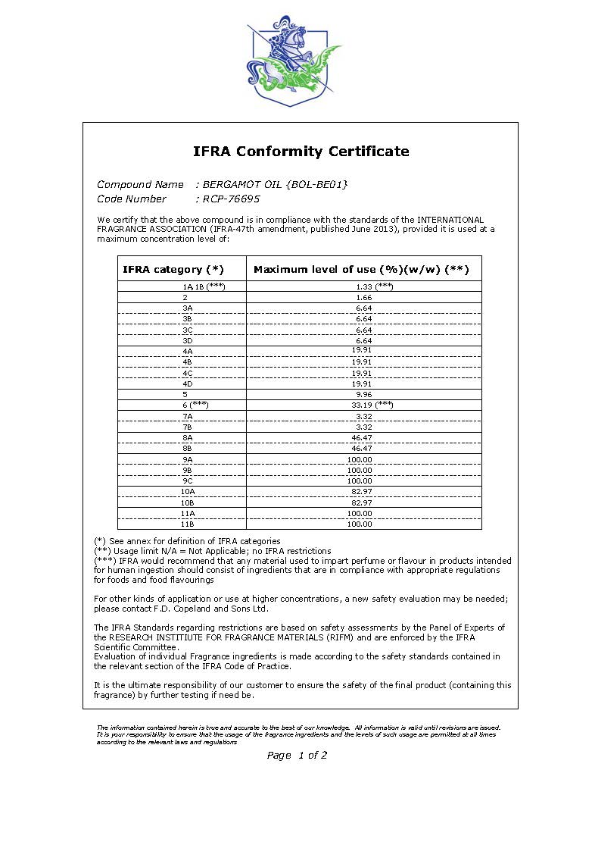
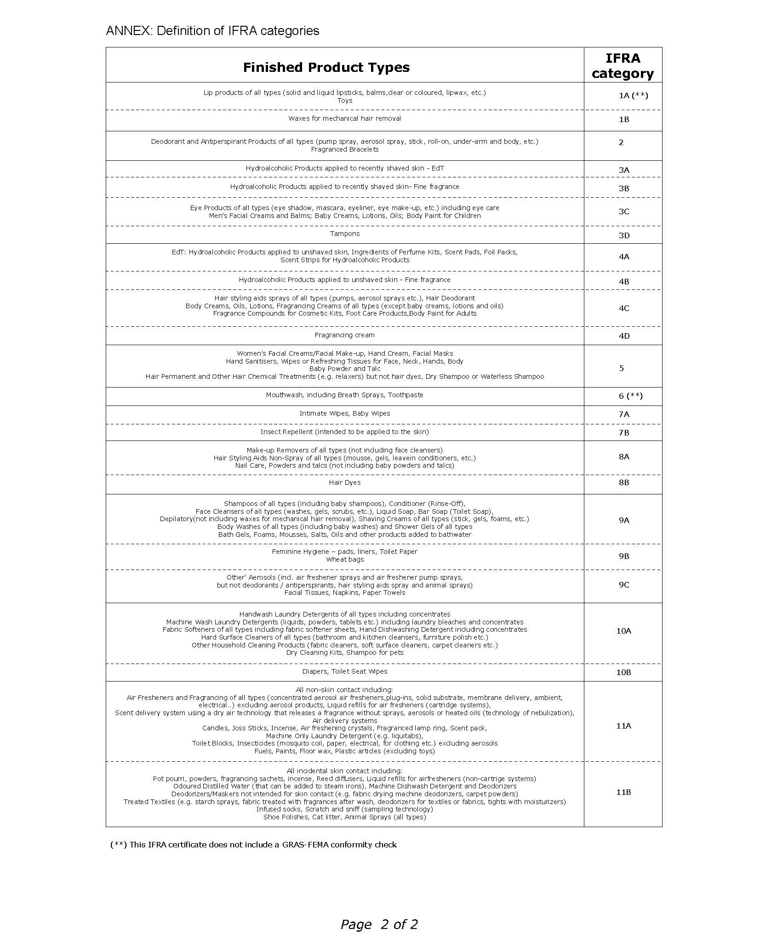
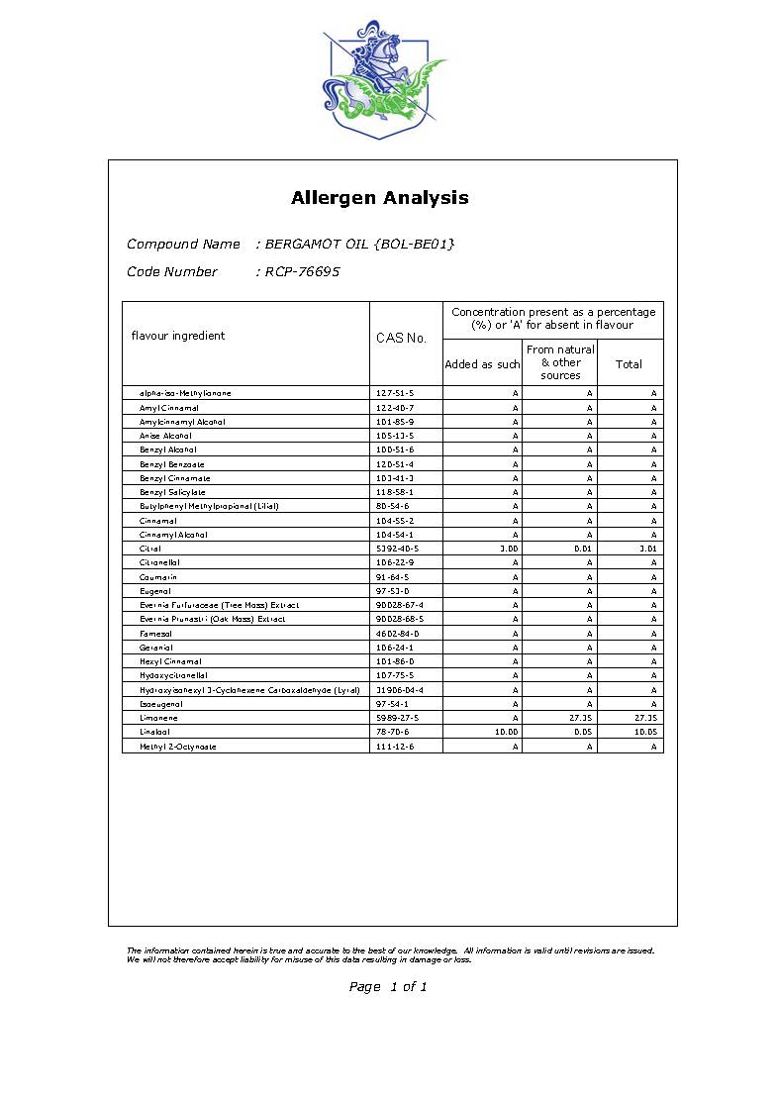

Appendix 4: Miscellaneous

The stability report, packaging material information and product carton insert are maintained electronically with the PIF by the Responsible Person. They are available on request.

